Lab 6: Mass Movement Name:__________________________

- We can model a landslide as a regular volume of sediment being moved downhill by gravity uniformly – although this is a massive simplification. Refer to the schematic below. (4pts)
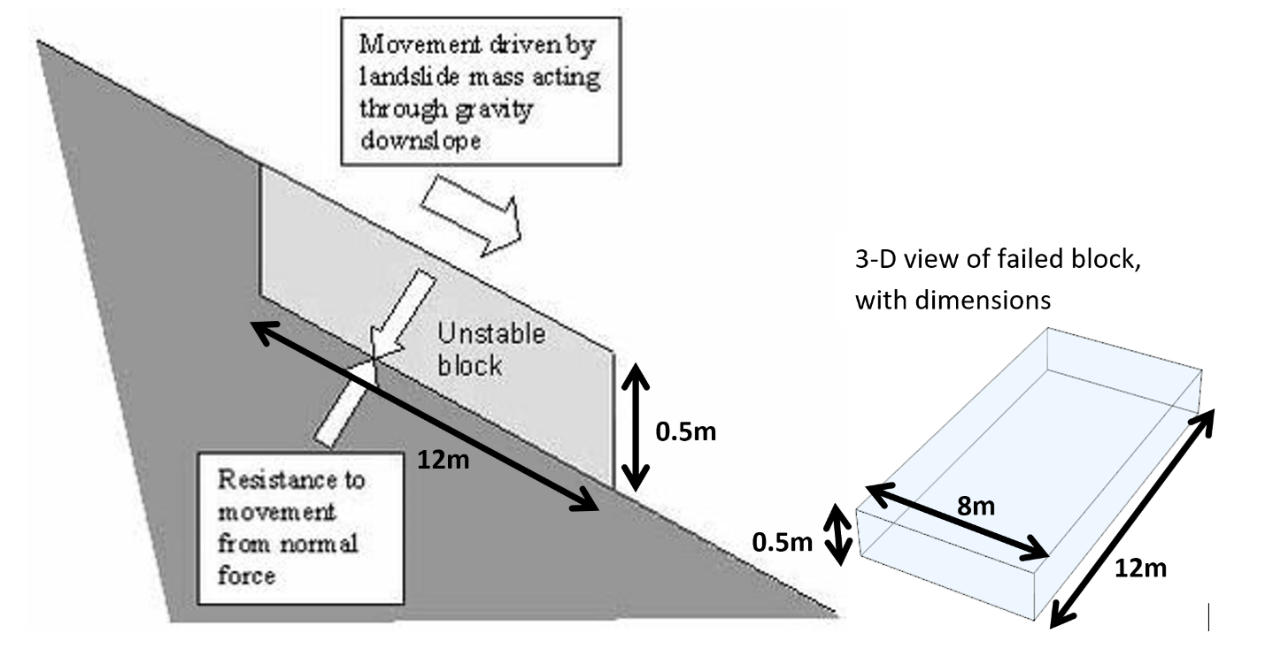
- Knowing that the volume of this block is equal to width * length * height, and that it is comprised entirely of quartz sediment (which weighs 2600 kg/m³), what is the mass of this block?

- We can measure how much energy this sediment block has using the basic gravitational potential energy equation: PE = mass * gravitational constant * height. Gravitational constant g = 9.81 m/s². If the block is at an elevation of 400m before it begins to slide, how much potential energy does it have? (kg*m²/s² = J)

- Once the sediment begins to move, potential energy is converted into kinetic energy: KE = 0.5 * mass * velocity² . Assuming all potential energy from 1b. is converted into kinetic energy, what is the velocity of the sediment as it reaches the bottom of the slope?

- Your answer for 1c should be in meters per second. Convert this value to miles per hour (1 mile = 1609.34 meters, 1 hour = 3600 seconds). Does this value seem reasonable? Do you think the sediment would move this fast in real life? Hint: what force have we left out of our analysis?

- Instead of a landslide, let’s consider soil creep. Soil creep can be modeled with the simple linear equation: q_{s} = k_{d} * S where q_{s} is the rate of soil creep in cm/yr, k_{d} is a given sediment flux diffusion constant, and S is the slope of the hill. The sediment flux diffusion constant basically means how sediment will diffuse downhill (this constant is governed by a number of factors) – a higher number corresponds to a faster rate of soil creep. Consider the diagram below. (3pts)
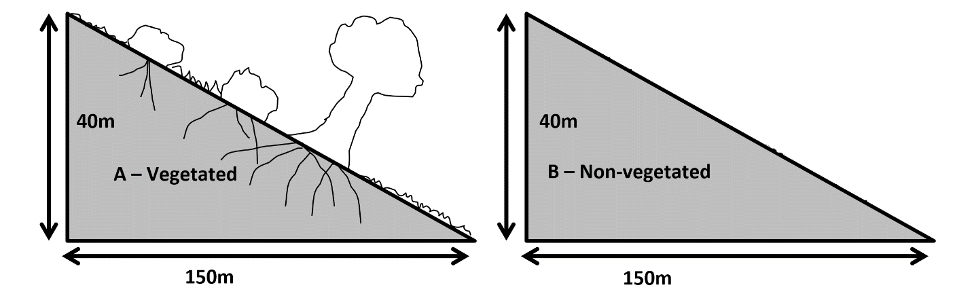

- Calculate the slope of the hills.

- In case A, the value of k_{d} is 1.1. In case B the value of k_{d} is 4.58. How many centimeters per year does each soil move downhill?

- Why is there a difference in diffusion rate and soil creep between the two? Yes, the difference is vegetation, but how does vegetation affect soil creep?

Part 2

A deadly landslide occurred in 2014 when the north bank of Stillaguamish River, Washington collapsed, now referred to as the “Oso Landslide”.
In Google Earth, enter in the search tab: 48°16'57"N 121°50'53"W or “Oso Landslide Memorial” to view the landslide and answer the following questions.

- On Google Earth, click the “show historical imagery” icon on the top toolbar () and use the left arrow to view imagery before April 2014. Use the polygon tool (from the Ruler tool) to measure the areal extent of the landslide. Report the area in both km² and mi². (1pt)

- Click through and explore the historical imagery of this site. (1pt)

  - Has another landslide occurred in the past on this slope? If yes, what year(s)?

  - When has river migration occurred along this slope?

- Based on your answers to #2, how did the river contribute to landslide occurrence at this site? (1pt)

